Women Dem Website

Meetings:
Meetings are held on the 2nd Tuesday of the month at 5:30 pm. Email us for more information.

Contact info:
dwhc1977@gmail.com

Follow us:
https://www.facebook.com/DWHC1977

Board Photo:
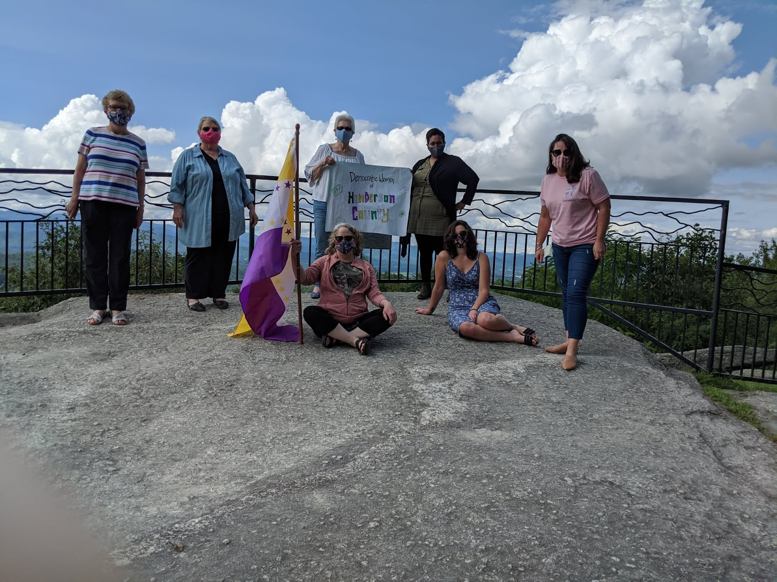

Logo:

More photos of our fun:
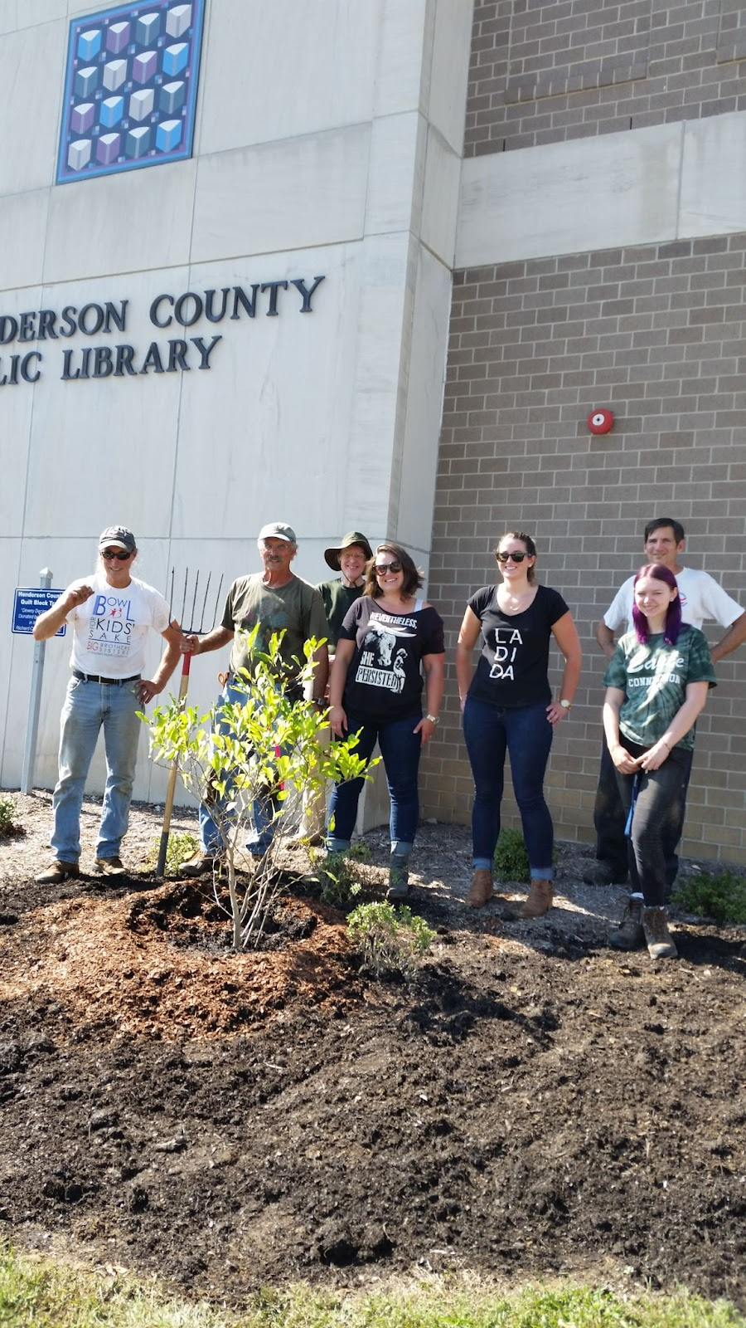Planting trees!

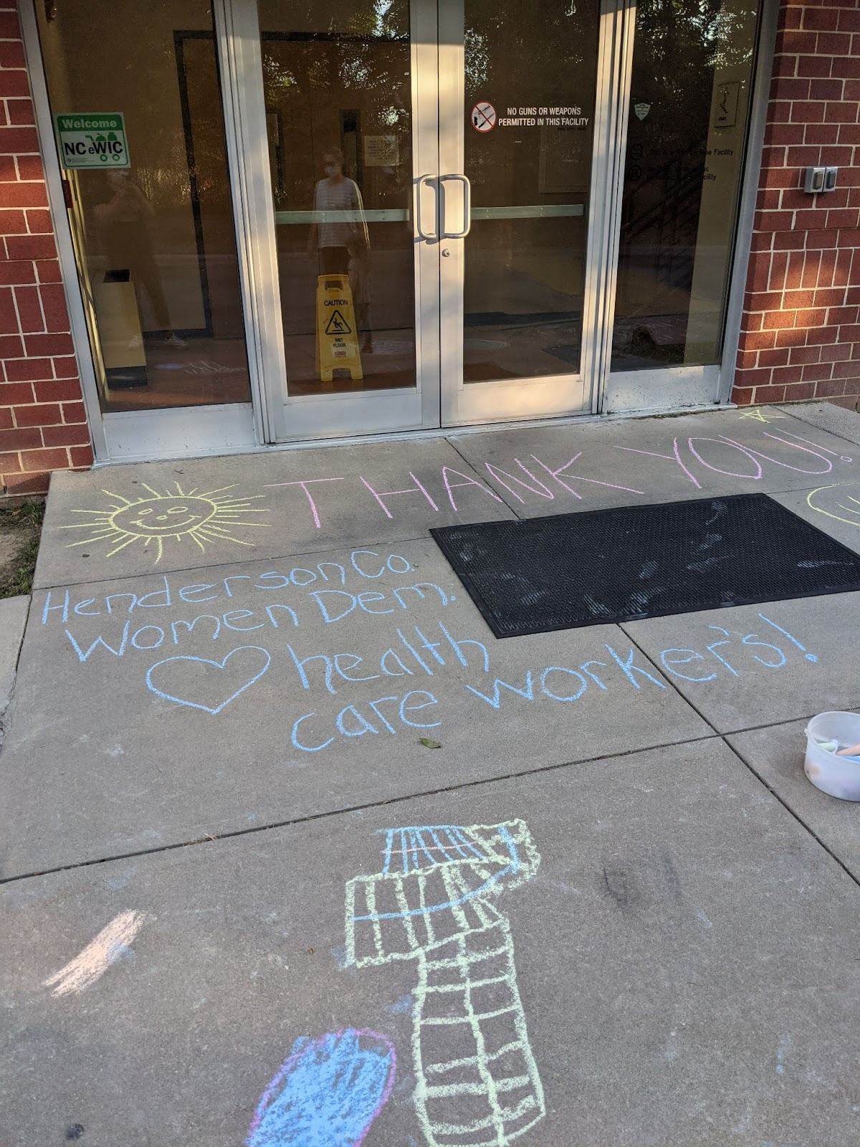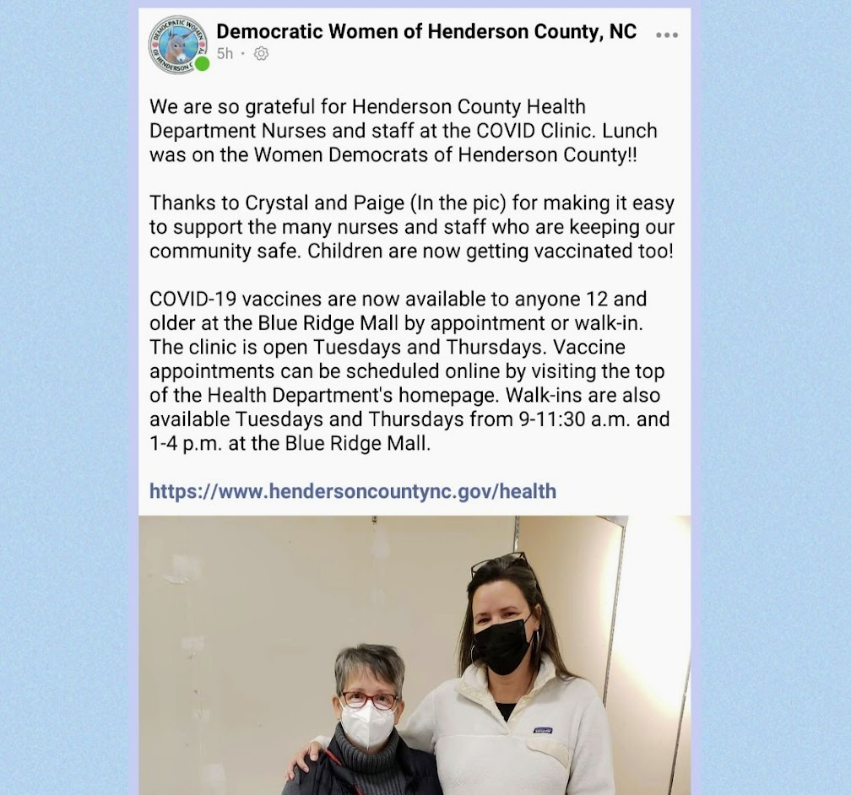
Loving on our healthcare workers!

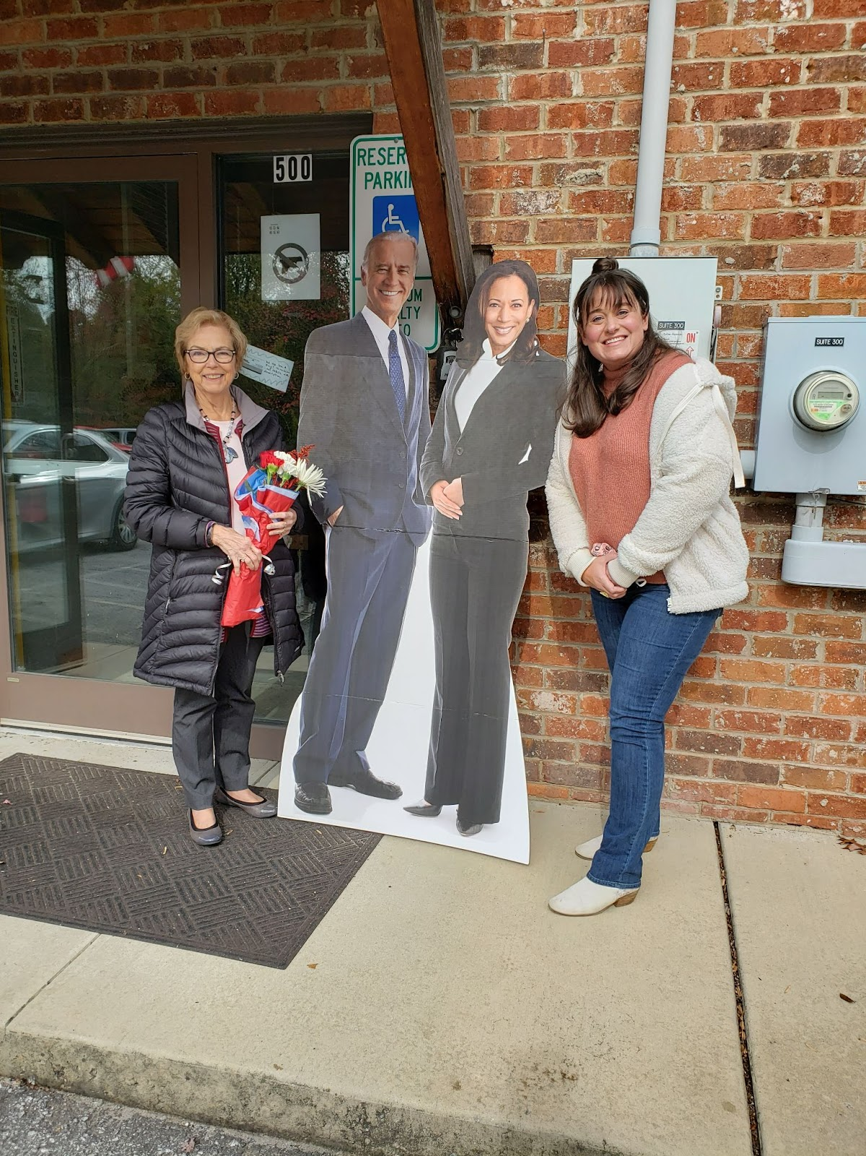

History:
The Democratic Women of Henderson County were founded in 1977 by Mae Alexander, Phyllis Capps, Elizabeth Clark, Billie Dalton, Pat Gossett, Lucy Miller, Marilyn Miller, Ruth Semashko, Bea Sumner, and Sylvia Waters.
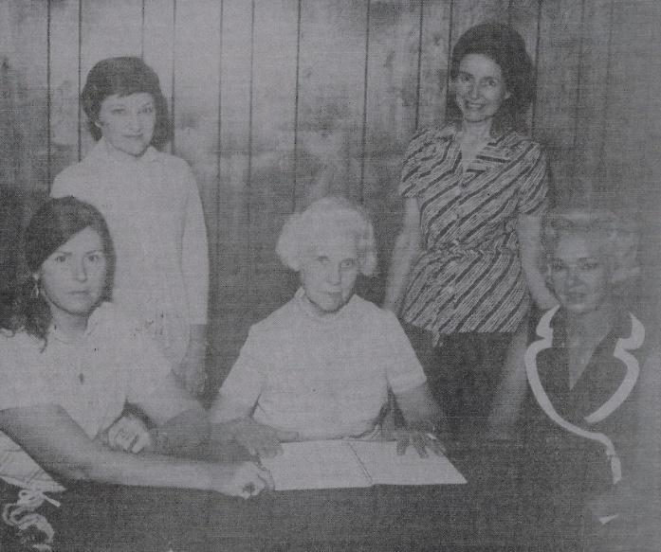
1977 Board Members. Left to right seated: Elizabeth Clark, Lucy Miller (president), Phyllis Capps; standing: Ruth Semashko, and Marilyn Miller.

